1.Update no_of copies after insert in transaction

create trigger after_insert after insert on transaction

-> for each row

-> begin

-> update book_master

-> set no_of_copies = no_of_copies - 1

-> where mb_id = (select mb_id from book_detail

-> where book_id = new.book_id);

-> end;

-> //

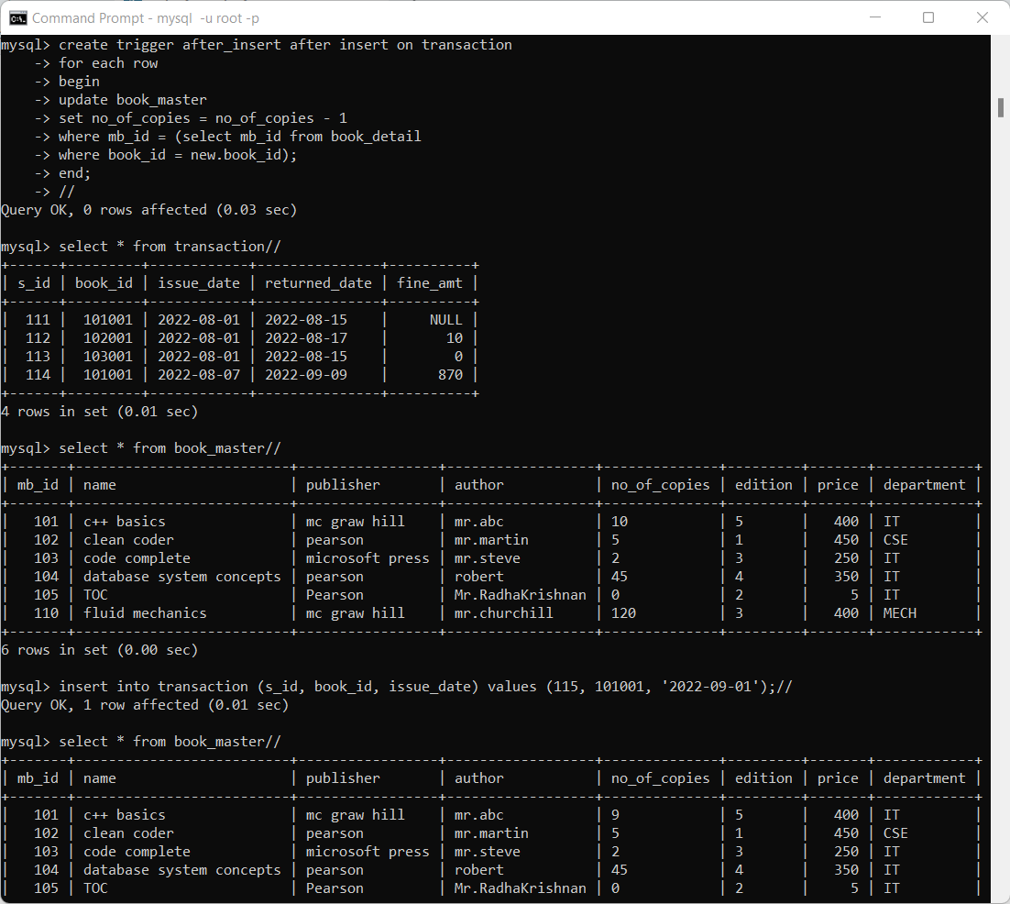

2. update no_of_copies when returned

Create trigger after_update after update on transaction

For each row

Begin

Update book_master

Set no_of_copies = no_of_copies+1

Where mb_id = (select mb_id from book_detail

Where book_id = new.book_id);

End;

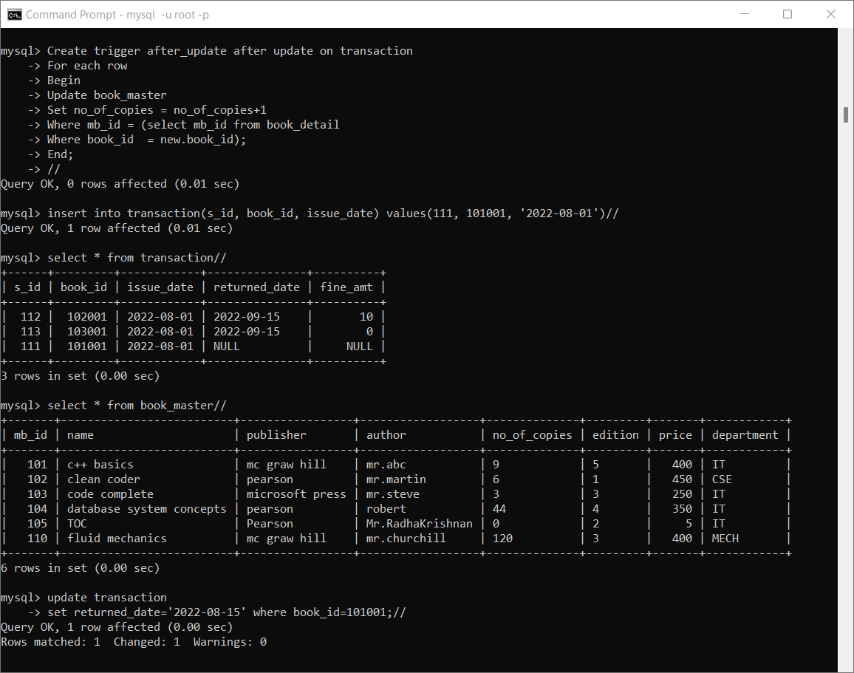

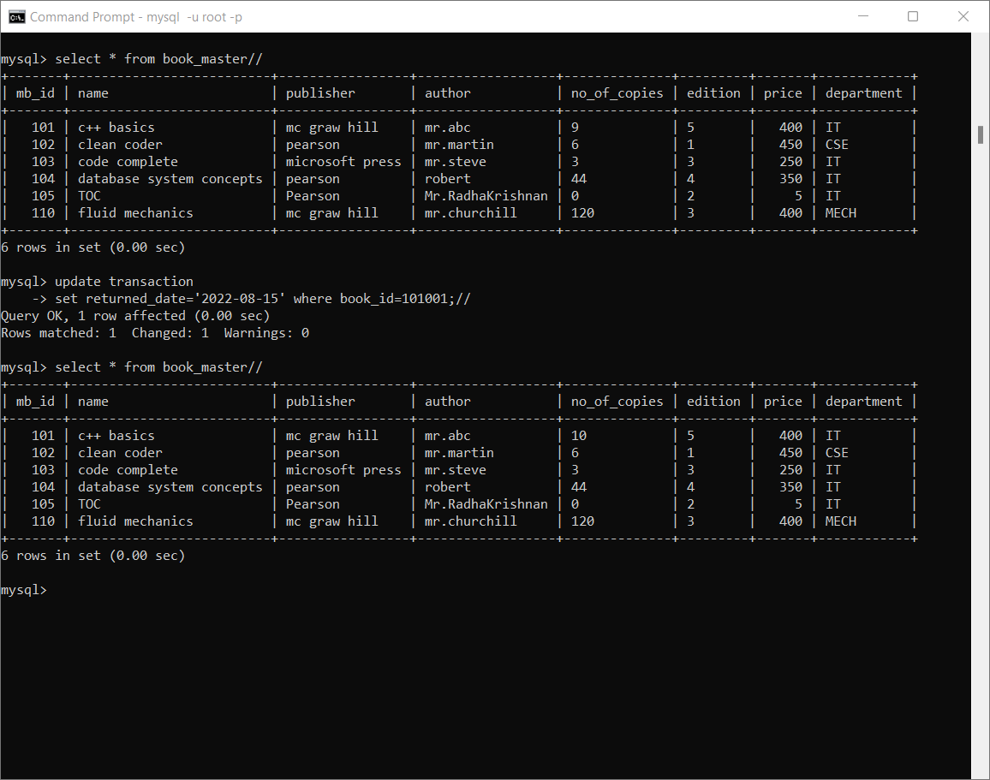

3. update no_of_copies when book deleted

Create trigger before_delete before delete on book_detail

For each row

Begin

Update book_master

set no_of_copies = no_of_copies-1

where mb_id = (select mb_id from book_detail where book_id = old.book_id);

end;

//

